Lab Assignment 4
Project Tasks
Part 1: Analyze the Current Design
1. Identify the primary key of the table.
SessionID
2. Write at least 5 functional dependencies.
FD1: SessionID -> SessionDate, SessionTime, StudentID, TutorID, CourseID, RoomID, SessionType, HourlyRate, DurationMinutes
FD2: StudentID -> StudentName, StudentEmail, Major
FD3: TutorID -> TutorName, TutorEmail
FD4: CourseID -> CourseTitle, Department
FD5: RoomID -> RoomBuilding, RoomCapacity
3. Describe the following anomalies:
o one insertion anomaly
- Can not add a new student, tutor, course, or room unless a tutoring session row is created for them.
o one update anomaly
- If a tutor’s email changes, every tutoring session row must be updated involving that tutor.
o one deletion anomaly
- If the only tutoring session for a certain room or course is deleted, all information about that room or course may be accidentally deleted from the database.
Part 2: Normalize to 3NF
STUDENT (StudentID, StudentName, StudentEmail, Major)
- PK: StudentID
TUTOR (TutorID, TutorName, TutorEmail)
- PK: TutorID
COURSE (CourseID, CourseTitle, Department)
- PK: CourseID
ROOM (RoomID, RoomBuilding, RoomCapacity)
- PK: RoomID
SESSION (SessionID, SessionDate, SessionTime, StudentID, TutorID, CourseID, RoomID, SessionType, HourlyRate, DurationMinutes)
- PK: SessionID
- FK: StudentID -> STUDENT(StudentID)
- FK: TutorID -> TUTOR(TutorID)
- FK: CourseID -> COURSE(CourseID)
- FK: RoomID -> ROOM(RoomID)
Part 5: Write Queries
Write and execute the following queries:
1. Display all tutoring sessions with:
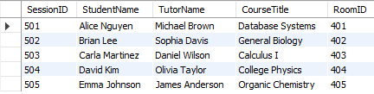
2. List all sessions for a specific student3
3. List all sessions conducted by a specific tutor
4. Count the number of sessions:
o per course
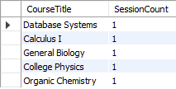
o per room
